# Department of Computing

# EE353: Computer Networks

# Class: BESE-11AB

**CLO 2: Apply the knowledge of Computer networking to understand contemporary networking issues**

**Lab 07: Wireless Access point Configuration**

**Date: 18-10-2023**

# Time: 10:00 to 01:00 and 2:00 to 05:00

# Instructor: Dr. Humma Gafoor

# Lab Engineer: Syed Muhammad Ali Musa

**Name:** Aimen Munawar

**Class:** BESE-13-A

**CMS ID:** 415867

**Lab 07: Wireless Access point Configuration**

**Introduction**

In [computer networking](https://en.wikipedia.org/wiki/Computer_networking_device), a wireless access point (WAP), or more generally just access point (AP), is a [networking hardware](https://en.wikipedia.org/wiki/Networking_hardware) device that allows other [Wi-Fi](https://en.wikipedia.org/wiki/Wi-Fi) devices to connect to a wired network. As a standalone device, the AP may have a wired connection to a [router](https://en.wikipedia.org/wiki/Router_(computing)), but, in a [wireless router](https://en.wikipedia.org/wiki/Wireless_router), it can also be an integral component of the router itself. An AP is differentiated from a [hotspot](https://en.wikipedia.org/wiki/Hotspot_(Wi-Fi)) which is a physical location where Wi-Fi access is available

**Objectives**

Configuration of Wifi Access point

**Tools/Software Requirement**

CISCO Packet Tracer

**Description**

https://www.youtube.com/watch?v=EbfWDCWraB8&t=30s

**Lab Task:**

Follow the given tutorial in the below YouTube link

<https://www.youtube.com/watch?v=EbfWDCWraB8&t=30s>

Create a Wireless Network and configure wireless access point in your topology. Attach at least 5 wireless end devices to the access point.

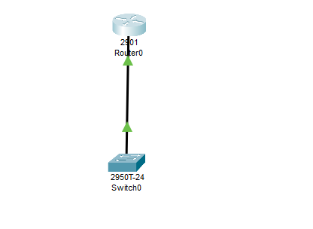

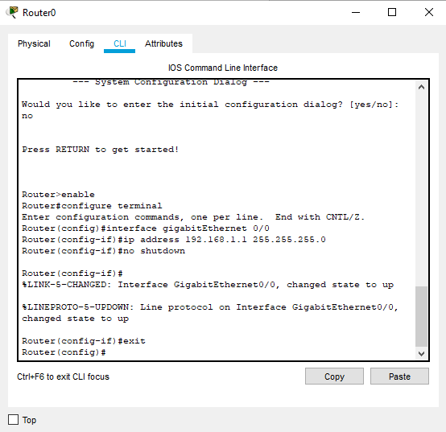

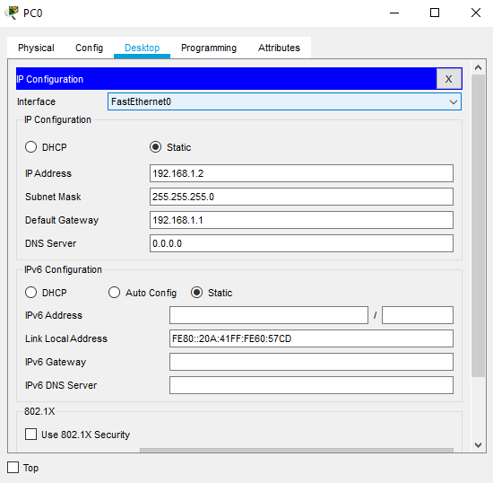

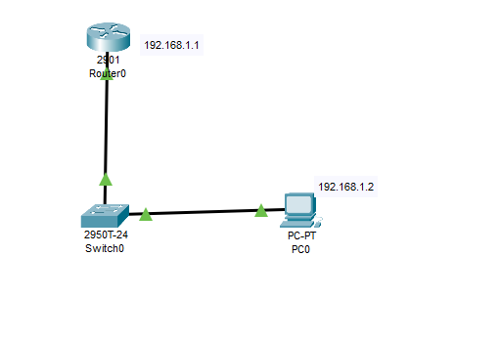

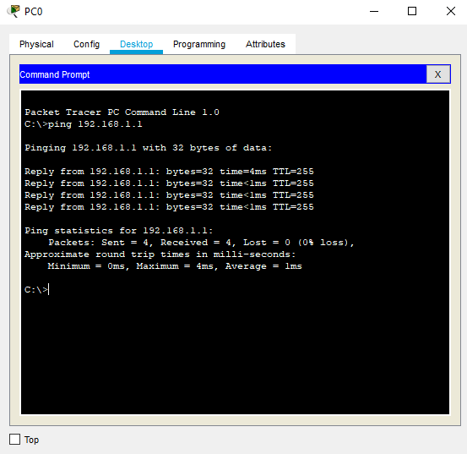

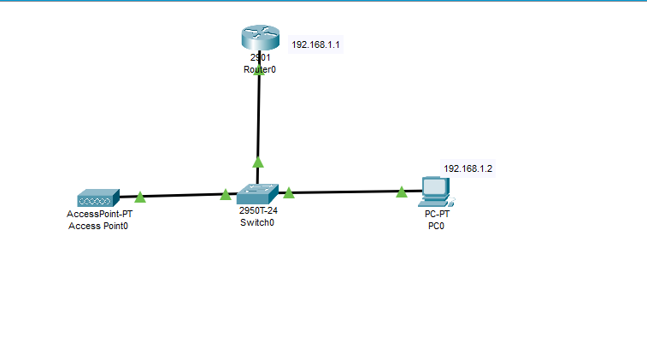

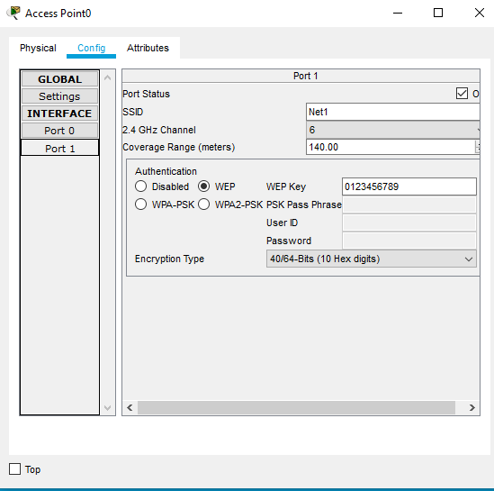

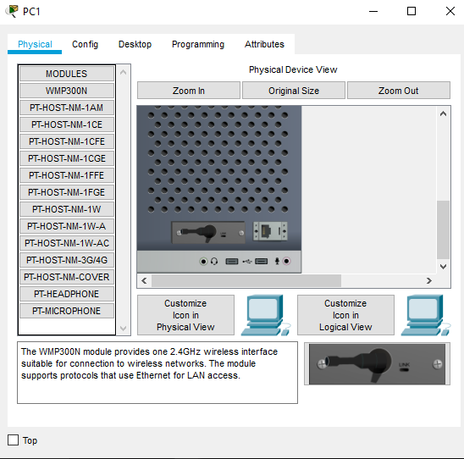

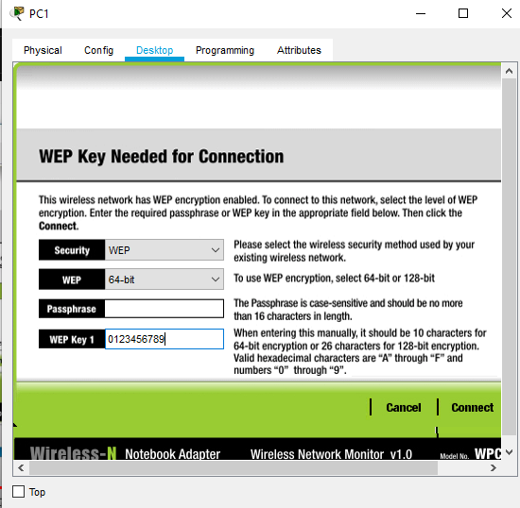

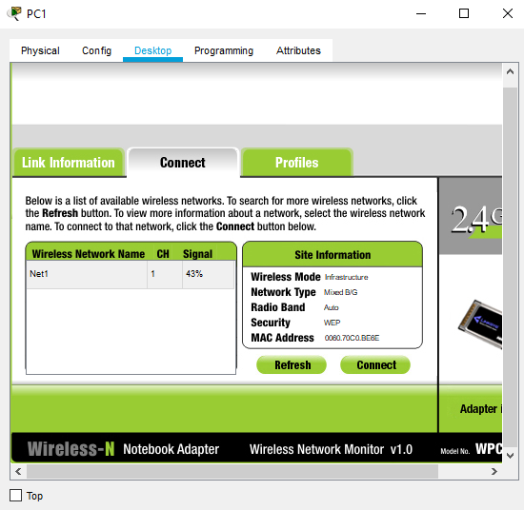

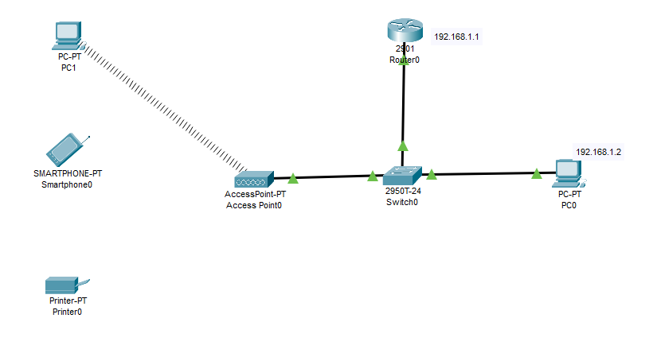

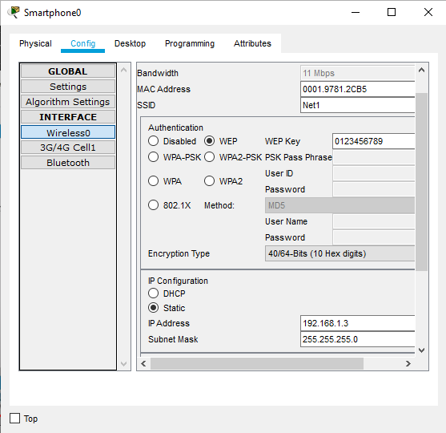

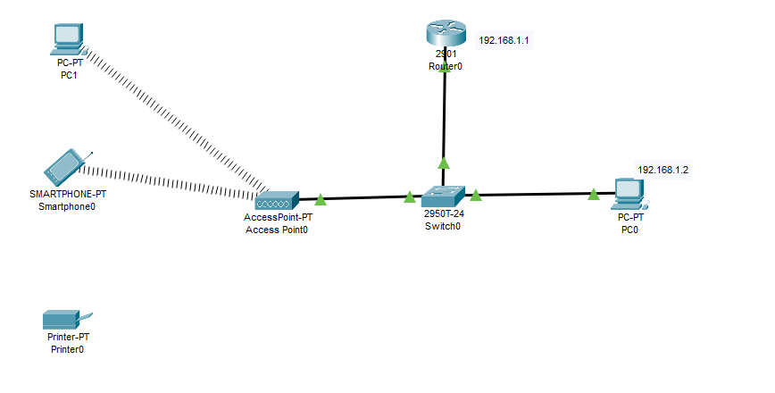

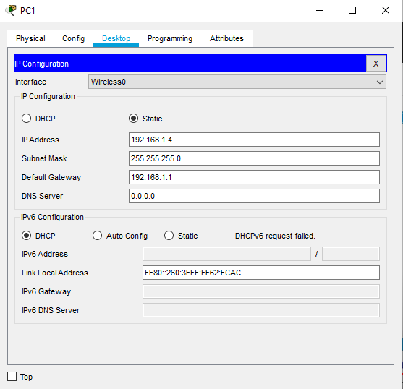

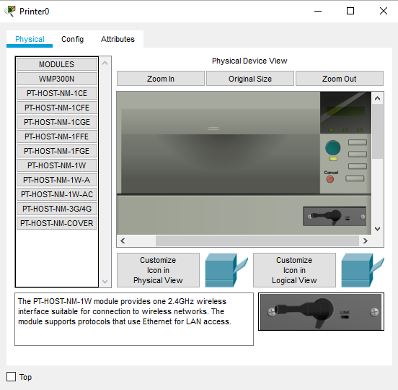

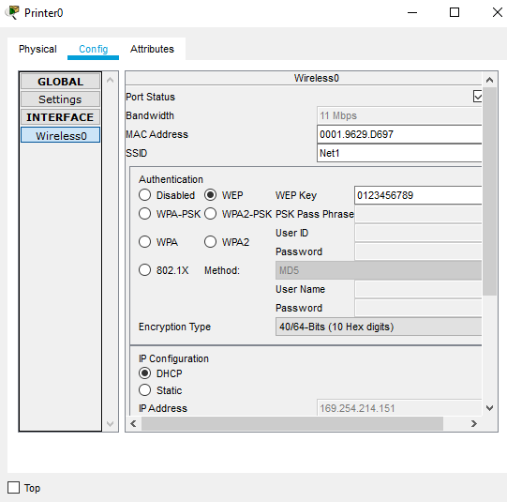

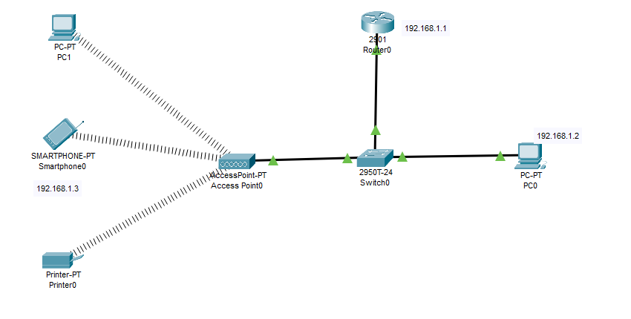

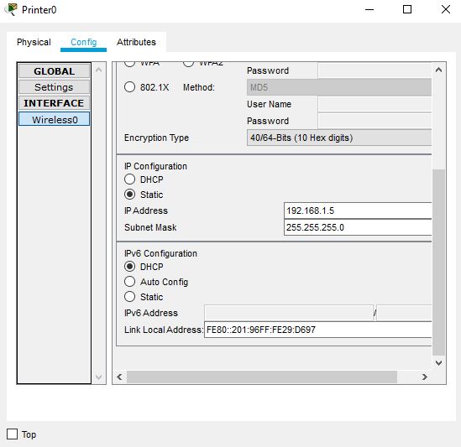

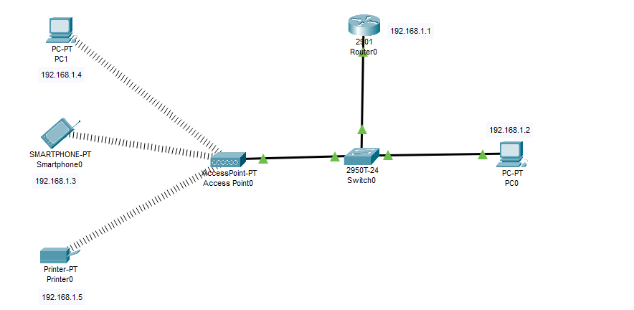

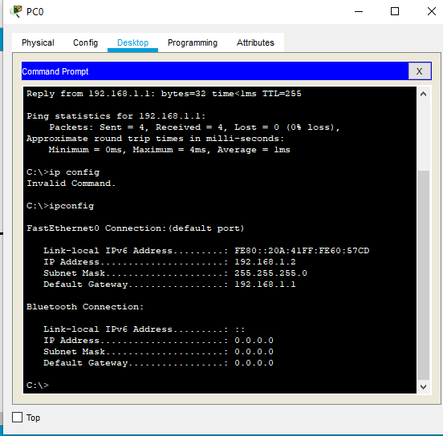

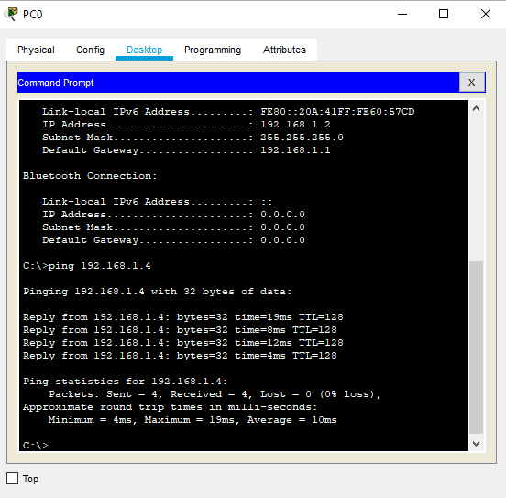

**Deliverables**

Zip and Upload all .pkt files

**Grade Criteria**

This lab is graded. Min marks: 0. Max marks: 10.